**NEURAL NETWORK AND DEEP LEARNING ASSIGNMENT_5 RAKESH KODELA_700727088**

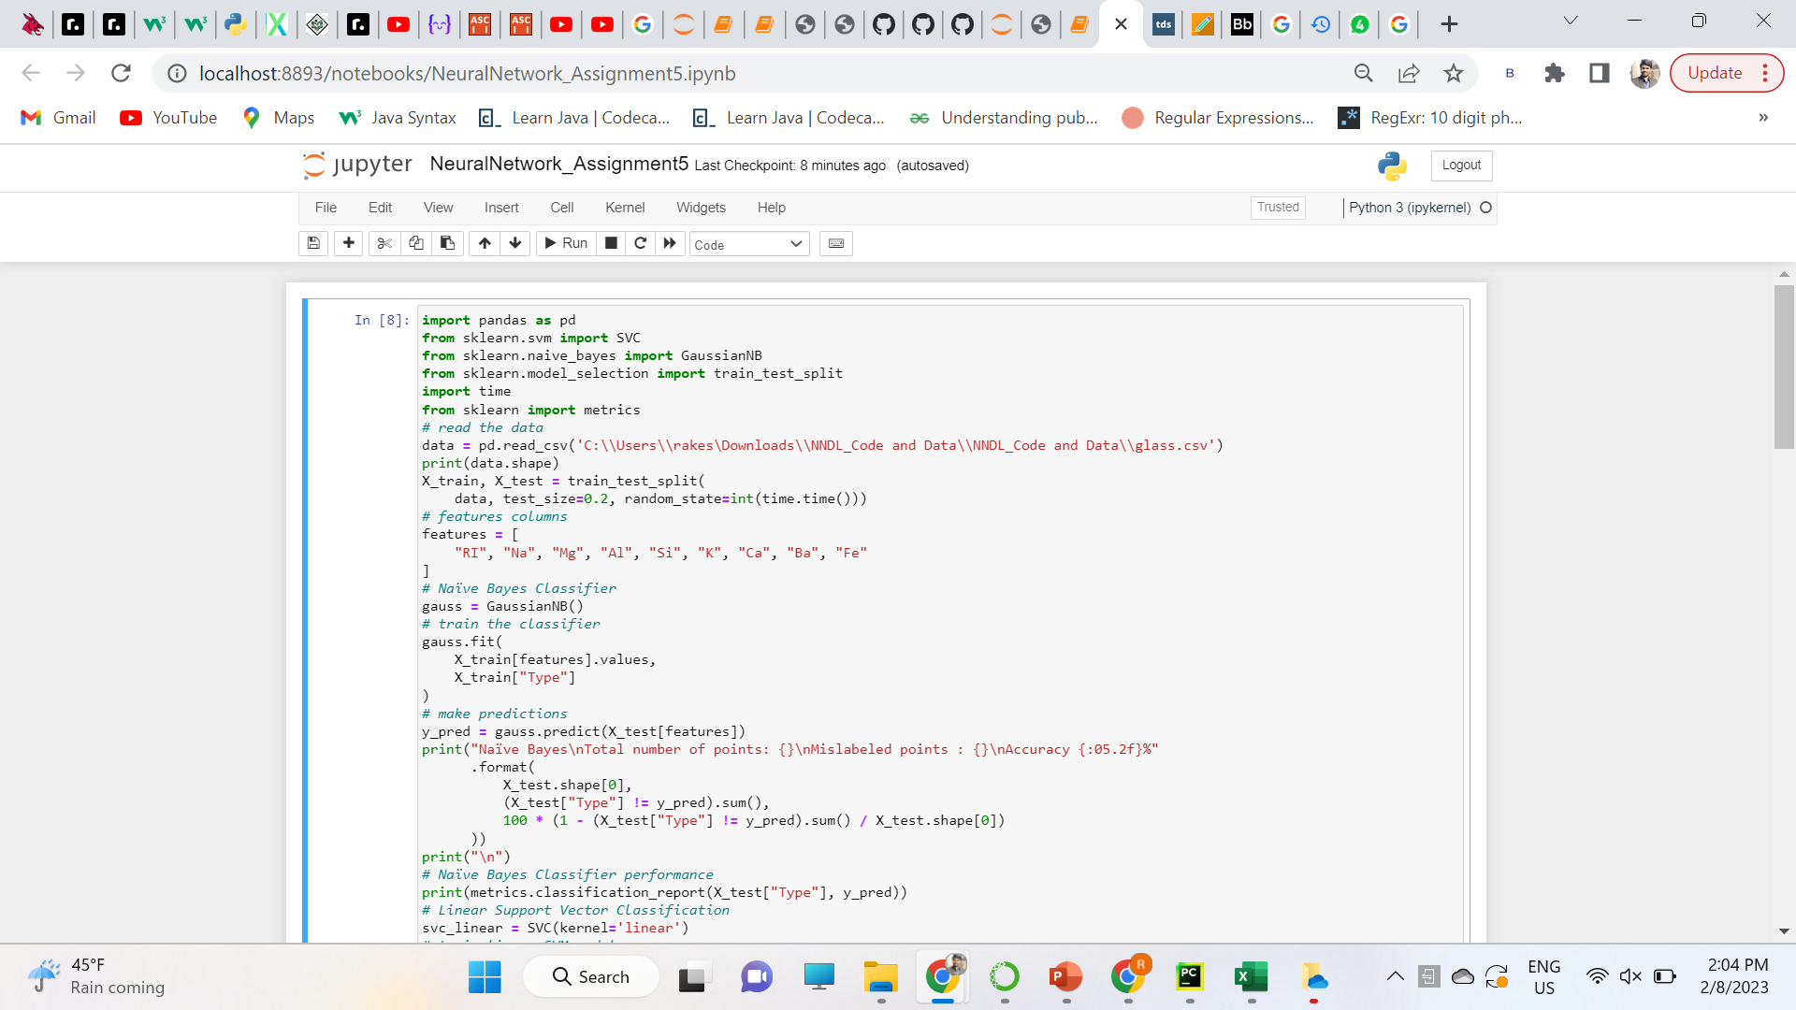

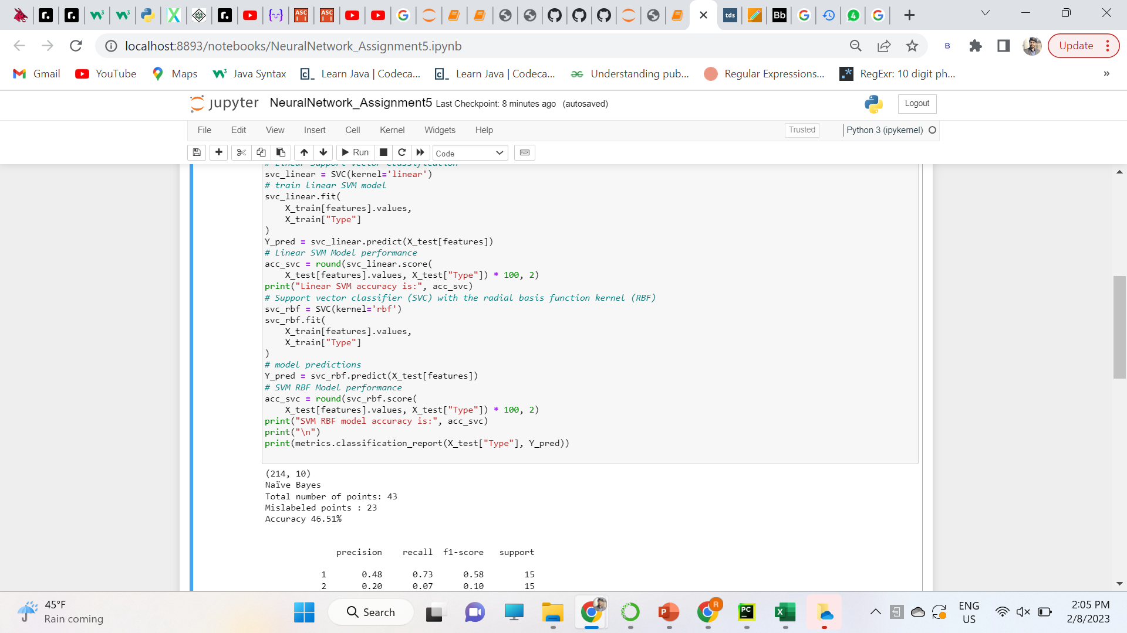

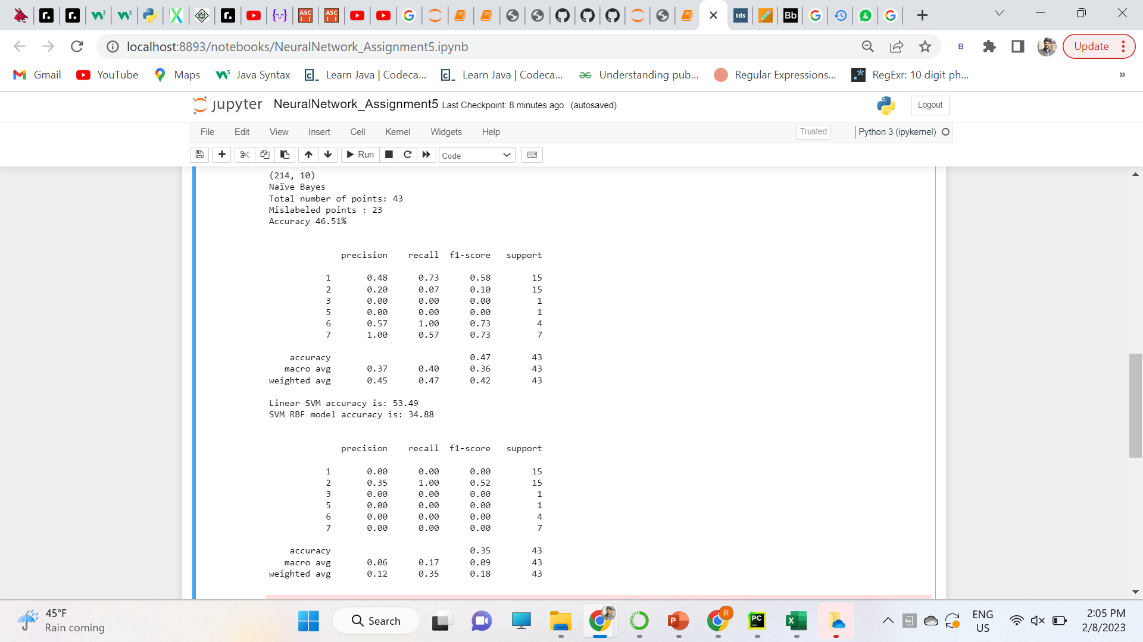

**GITHUB LINK:**

[**https://github.com/rakeshkodela/NeuralNetwork_Assignment5**](https://github.com/rakeshkodela/NeuralNetwork_Assignment5)